

**Analyzing**

**Alzheimer'sandIts**

**RiskFactors**

**Undersupervision**

**MohamedAbdelmawla**

**MicrosoftDataEngineer**

**Agenda**

**Problem** 0 **Statement** 1.

**Project**

02. **Overview** Objectives and Goals

**Data Collection** 04 **and Analysis** .

**Exploratory**

05 **Data Analysis** .

03.

**Objectives and**

06.

**goalsDashboards**

**Our teammembers: **

**Alaa Yasser Menna Khaled Fatima Alzahraa Zaynap Ahmed Mazen Hatem Yahia Yasser**

**ProblemStatement** 

**Alzheimer's diagnosis is complicated by factors like comorbidities, age, and lifestyle. This project aims to analyze these variables to enhance early detection and treatment.**

**ProjectOverview**

**This project explores Alzheimer's disease in patients from different age groups, locations, and education levels. By analyzing related conditions like hypertension and key health metrics, we aim to enhance early diagnosis and care strategies.**

**Objectivesandgoals**

**Objective: Analyze Alzheimer's disease data to uncover insights related to demographic factors, medical history, cognitive assessments, and lifestyle choices.**

**Goal: Provide actionable insights for healthcare strategies, particularly for early intervention, risk factor management, and improving patient care.**

**DataCollectionandAnalysis** 01. 02. 03. 

**Data Collection:**

**The dataset includes**

**demographics, medical history, cognitive assessments (e.g., MMSE scores), and lifestyle choices from patient records, covering age, BMI, cholesterol, and health conditions like diabetes and cardiovascular disease.**

**Data Cleaning :**

**11-Removed duplicates and filled missing PatientID and Diagnosis. 2-Standardized formats (dates, gender, diagnosis).**

**3-Imputed missing cognitive scores using medians.**

**4-Removed outliers (e.g., unrealistic ages, BMIs).**

**Categorization:**

**1-Age grouped into ranges (e.g., 60- 65, 66-70).**

**2-BMI categorized by standard ranges.**

**3-Cholesterol levels as "High," "Normal," or "Borderline." 4-MMSE scores by cognitive function (Low, Moderate, High).**

**ExploratoryDataAnalysis**

01.**During the Exploratory Data Analysis**

**(EDA), significant correlations were**

**observed between various variables and Alzheimer's disease.**

02.**Functional Assessment (ADL) and MMSE showed**

**negative correlations with Alzheimer's diagnosis, with**

**coefficients of -0.36, -0.33, and -0.24. Lower scores in**

**these assessments increase the likelihood of Alzheimer's.**

**Behavioral Problems and Memory Complaints were coefficients of 0.22 and 0.30, indicating these issues** 04**increase the likelihood of the disease.**

.

03.**A decline in functional and cognitive**

**abilities serves as a strong indicator**

**of increased Alzheimer's risk.**

**positively correlated with Alzheimer's, with**

**Dashboard**

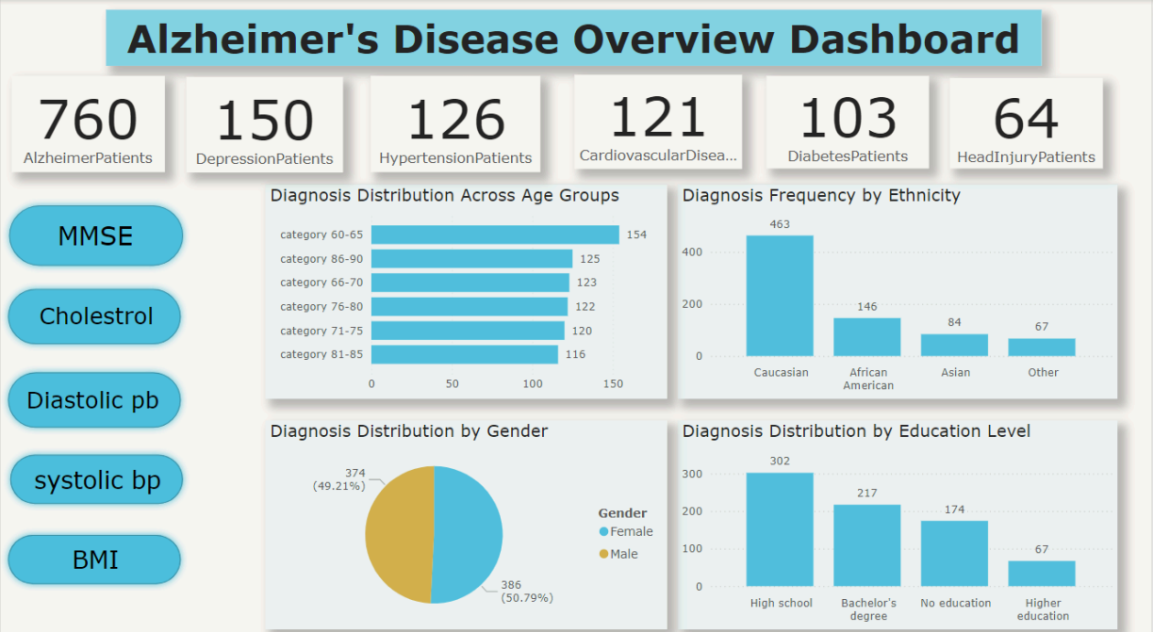

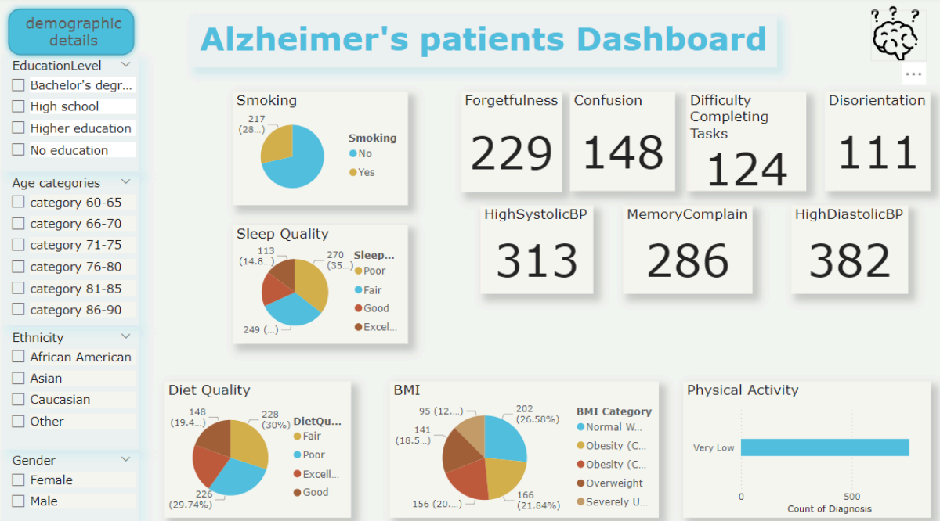

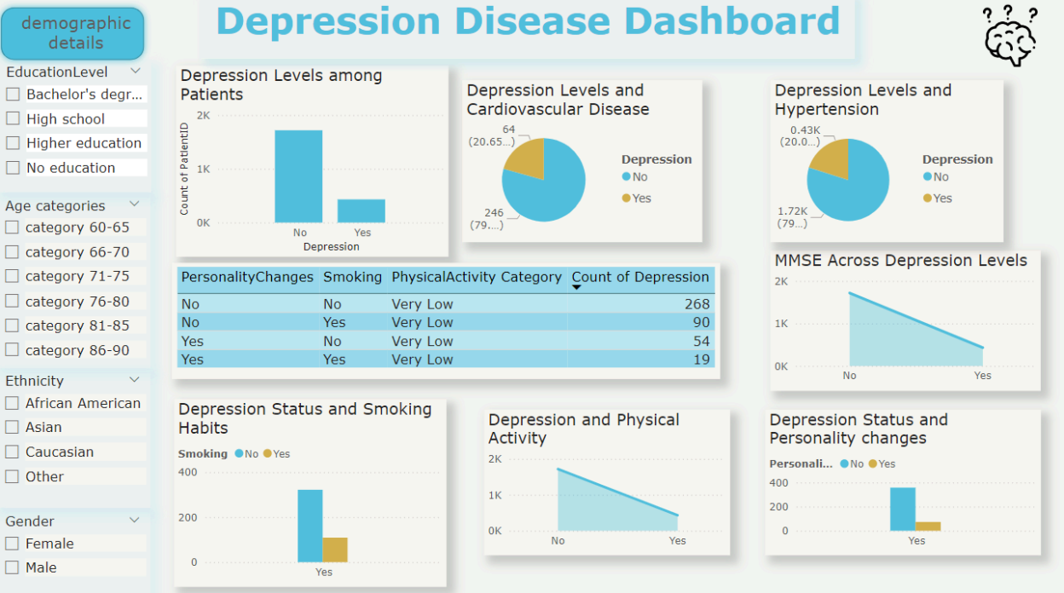

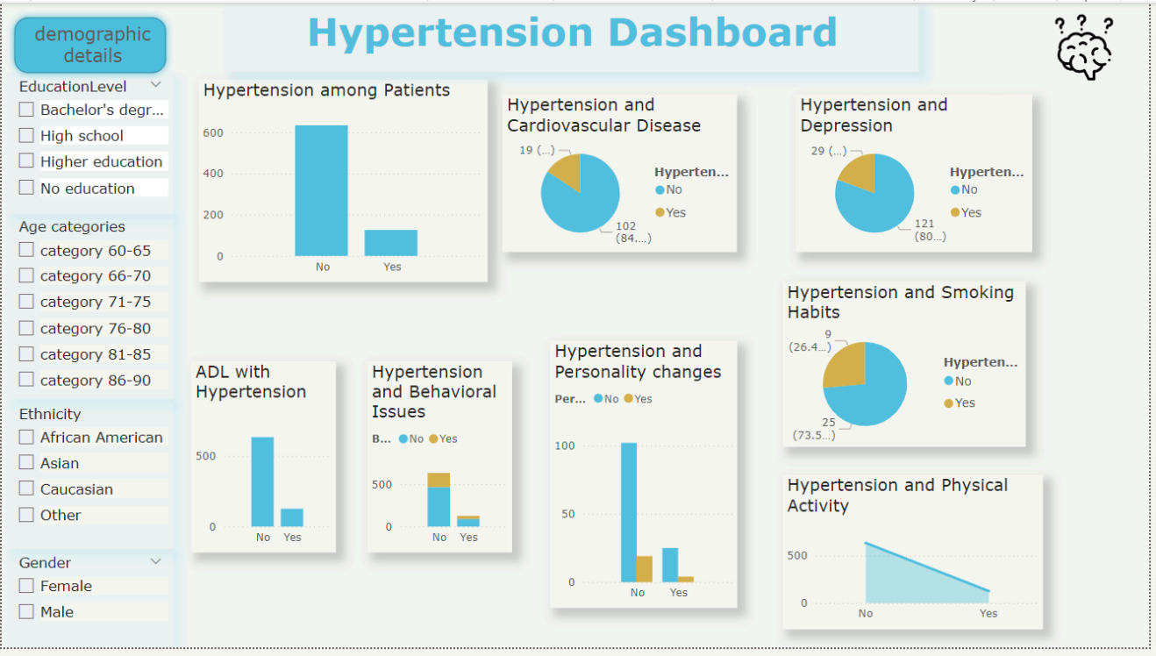

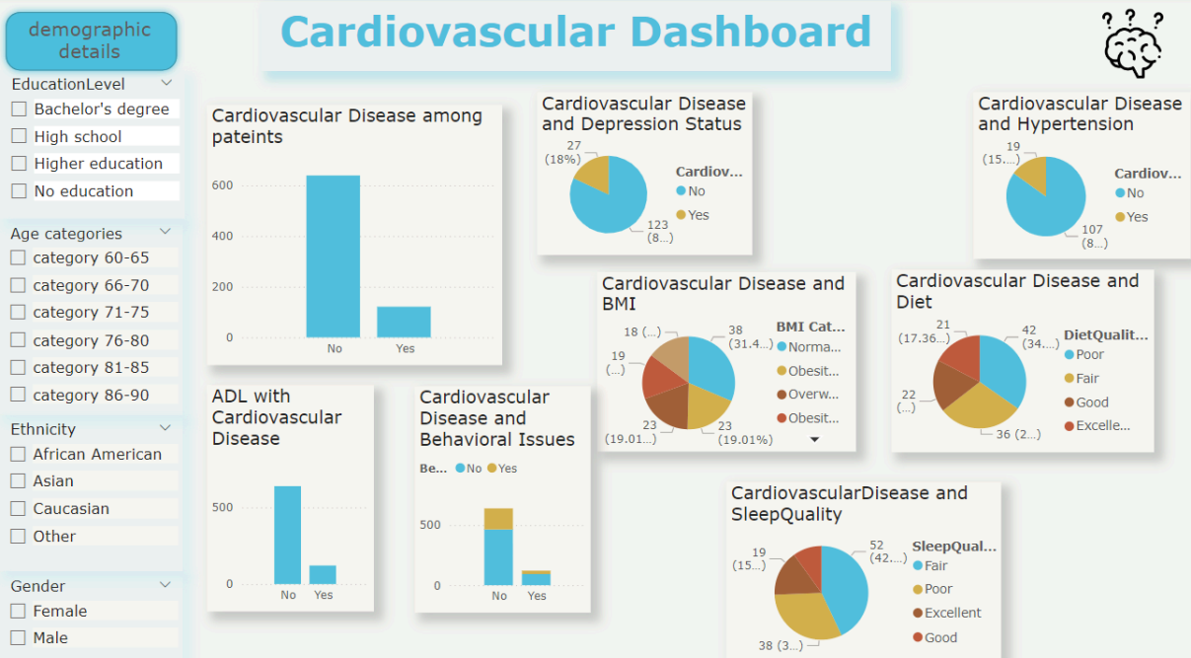

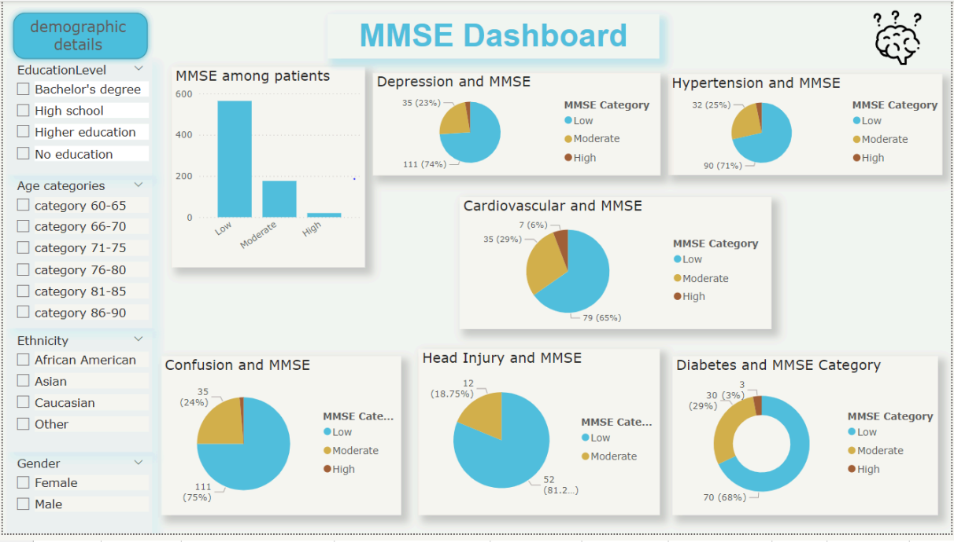





**Daistolic Systolic**



**Insights**

**Prevalence: 16.6% of Alzheimer's patients have hypertension, highlighting the need for integrated care.**

**Impact: Hypertensive Alzheimer's patients face more daily challenges and reduced physical activity, worsening both conditions.**

**Cardiovascular Disease: 19% of**

**Alzheimer's patients have it; 85% also have hypertension. Managing heart health and blood pressure is key.**



**Comorbidities: Many have cardiovascular disease, depression (80%), and are smokers, stressing the need for smoking cessation and mental health support.**

**Demographics: Affects both genders**

**equally; predominantly Caucasian. Most have high school education or less.**

**BMI, Diet, and Sleep: 31.4% are obese, with poor diet and sleep common, impacting health.**

**MMSE: Low MMSE scores are common in Alzheimer's patients, particularly those with depression (74%), hypertension (71%), cardiovascular disease (65%), confusion (75%), and diabetes (68%).**

**Cholesterol and Blood Pressure: No direct link was found between cholesterol or blood pressure levels and cognitive decline.**

**Disorientation and Forgetfulness: These worsen with age, particularly in obese individuals, but are less common in those with normal weight.**

**Diabetes: Significantly impacts weight, with younger patients showing more obesity and older patients more likely to be underweight**

**Health Factors: Diabetes and depression are the primary factors influencing weight changes across all age groups.**

**Depression: Affects both normal-weight and obese individuals, with varying influence across age groups.**

**BMI Distribution: Most patients have normal BMI, but obesity still raises Alzheimer's risk. Forgetfulness & BMI: Obesity raises**

**forgetfulness, a key Alzheimer's symptom.**

**Cardiovascular Disease & BMI: Obesity**

**increases Alzheimer's risk in heart**

**patients.**

**Hypertension & BMI: Obesity and high**

**blood pressure increase Alzheimer's**

**risk.**



**Depression & BMI: Obesity worsens cognitive decline in depressed patients.**

**Diabetes & BMI: Obesity and diabetes significantly raise Alzheimer's risk.**

**Sleep & Diet: Obesity is linked to poor sleep and diet, accelerating cognitive decline.**

**Recommendations**

**Integrated Care: Manage Alzheimer's alongside conditions like hypertension, diabetes, and cardiovascular disease to improve overall outcomes.**

**Mental Health and Depression Support: Provide targeted mental health support, especially for patients with depression, as it influences cognitive decline and weight management.**

**Physical Activity and Lifestyle Changes: Encourage exercise, improve sleep quality, and promote healthier diets to address obesity and slow cognitive decline.**

**Weight Management: Prioritize reducing obesity, particularly for those with Class 2 obesity, through tailored diet, exercise, and sleep programs to lower Alzheimer's risk.**

**Diabetes and Cardiovascular Management: Focus on managing diabetes, high blood pressure, and heart health, particularly in obese and hypertensive patients, to reduce Alzheimer's risk.**

**Educational and Age-Specific Interventions:**

**Younger Patients (60-70 years): Emphasize diabetes management and weight reduction.**

**Older Patients (71-85 years): Address forgetfulness and depression with cognitive therapies and lifestyle changes.**

**ApplyingRandomForesttoValidateInsights**

**why Random** 

**Forest**

**Grid Search**

**RandomForestclassificationReport**

****Thank

youvery

much!